**Project Design Phase-II**

**Data Flow Diagram & User Stories**

|  |  |
| --- | --- |
| Date | 03 October 2022 |
| Team ID | PNT2022TMIDxxxxxx |
| Project Name | Project - xxx |
| Maximum Marks | 4 Marks |

**Data Flow Diagrams:**

A Data Flow Diagram (DFD) is a traditional visual representation of the information flows within a system. A neat and clear DFD can depict the right amount of the system requirement graphically. It shows how data enters and leaves the system, what changes the information, and where data is stored.

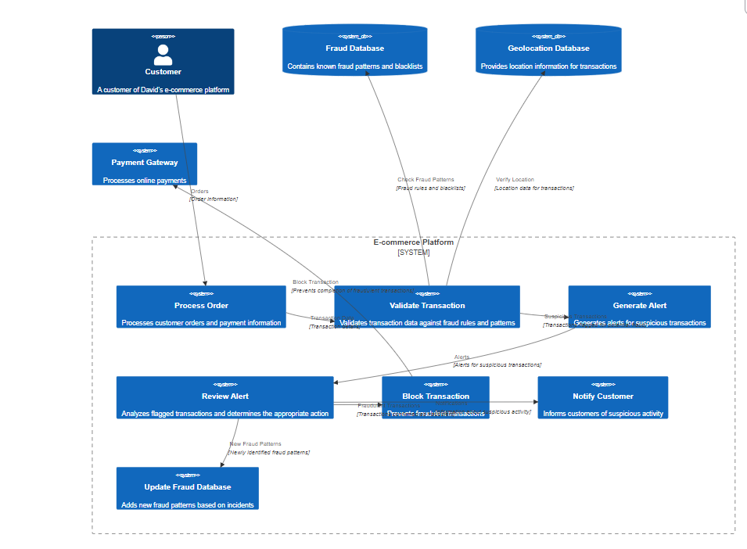

**User Stories**

Use the below template to list all the user stories for the product.

|  |  |  |  |  |  |  |
| --- | --- | --- | --- | --- | --- | --- |
| **User Type** | **Functional**  **Requirement (Epic)** | **User Story**  **Number** | **User Story / Task** | **Acceptance criteria** | **Priority** | **Release** |
| E-commerce Business Owner | Data Upload and Model Training | USN-1 | As an e-commerce business owner, I want to upload my transaction data to the system and train a fraud detection model tailored to my business. | I can successfully upload data in CSV format, select a model, initiate training, and view training progress. | High | Sprint 2 |
| Risk Analyst | Model Selection & Evaluation | USN-2 | As a risk analyst, I want to choose from different machine learning models, adjust model parameters, and evaluate the model's performance to optimize fraud detection. | I can select from a list of models, modify hyperparameters, initiate training and evaluation, and view performance metrics (accuracy, precision, recall, F1-score, AUC-ROC) and visualizations (confusion matrix, ROC curve). | High | Sprint 2 |
| Customer Support Agent | Real-time Fraud Prediction | USN-3 | As a customer support agent, I want to use the system to quickly check if a transaction is potentially fraudulent so I can take appropriate action. | I can input transaction details through a user-friendly interface, receive a clear prediction (fraudulent/not fraudulent) with a confidence score, and access additional information like predicted fraud type if available. | High | Sprint 4 |
| Online Consumer | Understanding Fraud Predictions | USN-4 | As an online consumer, I want to understand the factors that contributed to a fraud prediction so I can be more aware of potential risks. | If a transaction is flagged as potentially fraudulent, I can view a clear explanation of the key features influencing the prediction (e.g., unusual transaction amount, suspicious location). | Medium | Sprint 4 |